Liquid Level Control System

Using PID control

Sriram S

Smart Manufacturing Department

IIITDM Kancheepuram

Tamilnadu, India.

Deepaksethupathy R

Smart Manufacturing Department

IIITDM Kancheepuram

Tamilnadu, India.

*Abstract*— the purpose of this project is to demonstrate an innovative approach for low cost continuous liquid level monitoring based on PID control system. Most of the traditional measuring systems were designed and implemented by complicated hardware circuitry. It made the product expensive, with low functionality and with limited precision. With digital measurement technology, more of the instrument can be substituted by software, and sensors. Using this approach the cheaper and more versatile measurement system can be developed. A prototype of a liquid level monitoring system based on ultrasonic sensors, water pump, and Arduino IDE is developed for measuring liquid level accurately and accordingly maintaining the level of liquid close to the reference level. Set level can be changed to introduce flexibility. LCD display is integrated to allow real time monitoring.

Keywords—Liquid level control, PID, Control system, Arduino, Ultrasonic sensor.

# Introduction

Many industrial and scientific processes require knowledge of the quantity of content of tanks and other containers. In many instances it is not possible or not practical to directly view the interior. The more obvious industrial applications include: tank level gauging of milk, beer or wine in food and beverage industry; level gauging of acid, oil and solvent vessels in chemical plants; level monitoring of water in reservoirs. Over the last several decades, computer control of manufacturing systems has been the focus of extensive research. Advances in microprocessor, computing, networking and interfacing technologies have improved capabilities of industrial measurement and monitoring systems substantially over the period. The availability of water resources on earth are limited and unevenly distributed. The conservation of our water resources depends on our wise use of these resources [1]. The development of virtual and open architecture monitoring systems shifts the focus of automation from being hardware centric to software centric, providing further flexibility. Therefore an experimental setup will be constructed to control liquid level in a tank using arduino IDE. In this project we are using ultrasonic sensor to measure liquid level.

# PID Control

PID control algorithms is a classical algorithm of the earliest development and application, the PID controller has the advantage of simple structure, control easily, good robustness and high accuracy. PID control is proportional, integral, differential control and its control principle diagram is shown in Fig.1 [2]

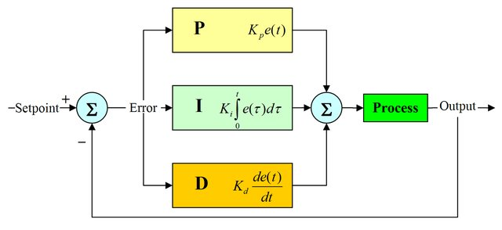

Fig1: PID Block Diagram

* Term **P** is proportional to the current value of the SP − PV error *e*(*t*). For example, if the error is large and positive, the control output will be proportionately large and positive, taking into account the gain factor "K". Using proportional control alone will result in an error between the set point and the actual process value, because it requires an error to generate the proportional response. If there is no error, there is no corrective response.
* Term **I** accounts for past values of the SP − PV error and integrates them over time to produce the *I* term. For example, if there is a residual SP − PV error after the application of proportional control, the integral term seeks to eliminate the residual error by adding a control effect due to the historic cumulative value of the error. When the error is eliminated, the integral term will cease to grow. This will result in the proportional effect diminishing as the error decreases, but this is compensated for by the growing integral effect.
* Term **D** is a best estimate of the future trend of the SP − PV error, based on its current rate of change. It is sometimes called "anticipatory control", as it is effectively seeking to reduce the effect of the SP − PV error by exerting a control influence generated by the rate of error change. The more rapid the change, the greater the controlling or dampening effect.

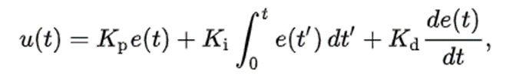

PID mathematical model[3]

# Mathematical modelling [4]

Consider the system shown below. The following parameters involved are:

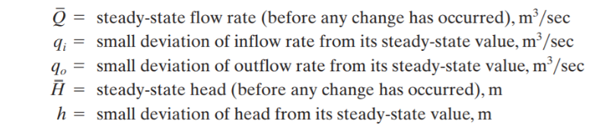

Usually the flow is divided according to the magnitude of Reynolds’s number. If Re >3000 or 4000, the flow is said to be turbulent. If Re<2000, flow is said to be laminar. For laminar flow, systems can be classified as linear differential equations. For industrial processes with connecting pipes and tanks, flow is turbulent and is represented as nonlinear differential equations. Since our region of operation is limited, such linear systems can be linearized.

**Resistance and Capacitance of Liquid-Level Systems:**

For our system, flow through an outlet, the resistance R for liquid flow in such a pipe or restriction is defined as the change in the level difference (the difference of the liquid levels of the two tanks) necessary to cause a unit change in flow rate; that is,

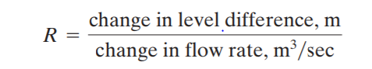

In this system the liquid spouts through the load valve in the side of the tank. If the flow through this restriction is laminar, the relationship between the steady-state flow rate and steady-state head at the level of the restriction is given by

Q = KH

Where Q = steady-state liquid flow rate, m3/sec

K = Coefficient, m2/sec

H = Steady state head, m

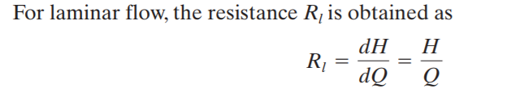

The laminar-flow resistance is constant and is analogous to the electrical resistance.

In many practical cases, the value of the coefficient K in equation), which depends on the flow coefficient and the area of restriction, is not known. Then the resistance may be determined by plotting the head-versus-flow-rate curve based on experimental data and measuring the slope of the curve at the operating condition. The tangent line to the curve at point P intersects the ordinate at point Thus, the slope of this tangent line is 2H/Q. Since the resistance Rt at the operating point P is given by the resistance Rt 2H/Q is the slope of the curve at the operating point

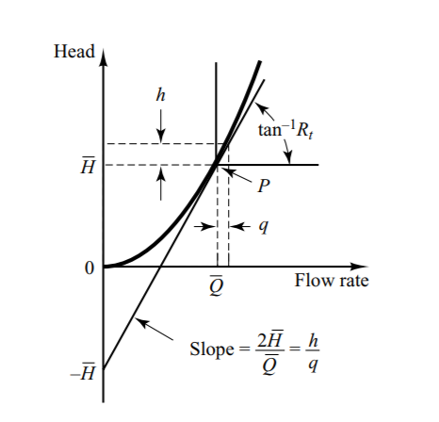 Consider the operating condition in the neighborhood of point P. Define a small deviation of the head from the steady-state value as h and the corresponding small change of the flow rate as q. Then the slope of the curve at point P can be given by

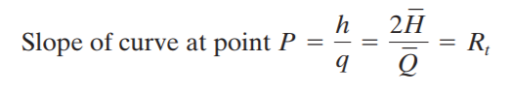

The linear approximation is based on the fact that the actual curve does not differ much from its tangent line if the operating condition does not vary too much. The capacitance C of a tank is defined to be the change in quantity of stored liquid necessary to cause a unit change in the potential (head). (The potential is the quantity that indicates the energy level of the system.)

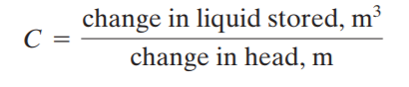

As stated previously, a system can be considered linear if the flow is laminar. Even if the flow is turbulent, the system can be linearized if changes in the variables are kept small. Based on the assumption that the system is either linear or linearized, the differential equation of this system can be obtained as follows: Since the inflow minus outflow during the small-time interval dt is equal to the additional amount stored in the tank, we see that

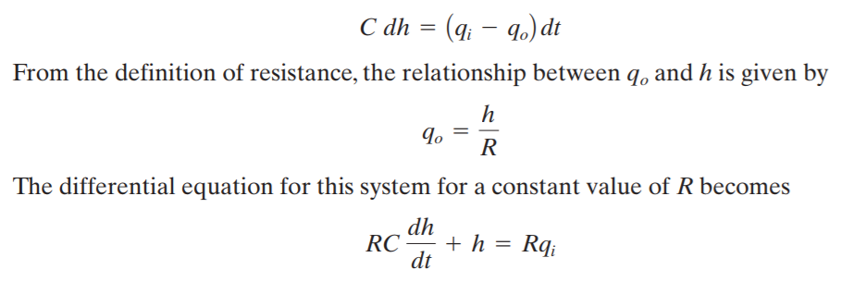

Note that RC is the time constant of the system. Taking the Laplace transforms of both sides of Equation, assuming zero initial conditions, we get

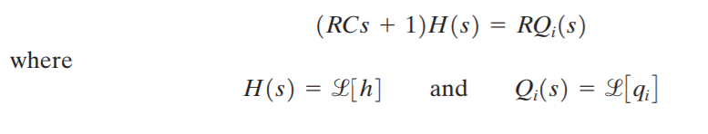

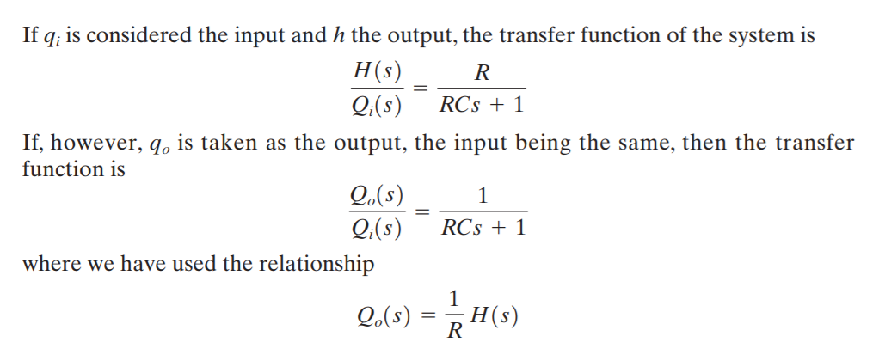

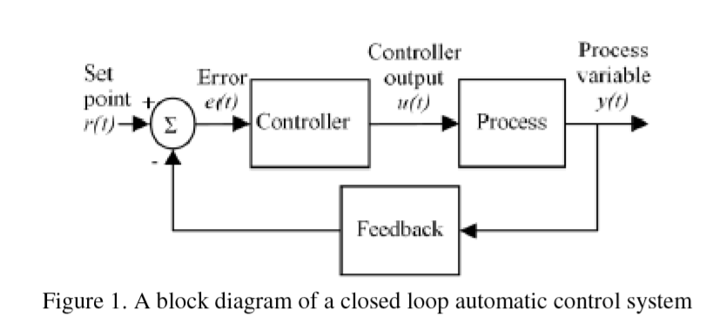

#### IV.Components used

## HC-SR04 Ultrasonic sensor:

#### Ultrasonic ranging module HC - SR04 provides 2cm - 400cm non-contact measurement function, the ranging accuracy can reach to 3mm. The modules includes ultrasonic transmitters, receiver and control circuit. The basic principle:

#### Using IO trigger for at least 10us high level signal,

#### The Module automatically sends eight 40 kHz and detect whether there is a pulse signal back.

#### IF the signal back, through high level , time of high output IO duration is the time from sending ultrasonic to returning.

#### Test distance = (high level time×velocity of sound (340M/S) / 2.

## Arduino UNO:

## The Arduino Uno is a microcontroller board based on the ATmega328 (datasheet). It has 14 digital input/output pins (of which 6 can be used as PWM outputs), 6 analog inputs, a 16 MHz ceramic resonator, a USB connection, a power jack, an ICSP header, and a reset button. It contains everything needed to support the microcontroller; simply connect it to a computer with a USB cable or power it with a AC-to-DC adapter or battery to get started. The Uno differs from all preceding boards in that it does not use the FTDI USB-to-serial driver chip. Instead, it features the Atmega16U2 (Atmega8U2 up to version R2) programmed as a USB-to-serial. "Uno" means one in Italian and is named to mark the upcoming release of Arduino 1.0. The Uno and version 1.0 will be the reference versions of Arduino, moving forward. The Uno is the latest in a series of USB Arduino boards, and the reference model for the Arduino platform; for a comparison with previous versions, see the index of Arduino boards.

## L298 Motor driver:

Dual Motor Controller Module 2A with Arduino. This allows you to control the speed and direction of two DC motors, or control one bipolar stepper motor with ease. The L298N H-bridge module can be used with motors that have a voltage of between 5 and 35V DC. There is also an onboard 5V regulator, so if your supply voltage is up to 12V you can also source 5V from the board.

The L298N is a dual H-Bridge motor driver which allows speed and direction control of two DC motors at the same time. The module can drive DC motors that have voltages between 5 and 35V, with a peak current up to 2A.

## DC 3-6 V Submersible water pump:

* DC Voltage: 2.5-6V
* Maximum lift: 40-110cm / 15.75″-43.4″
* Flow rate: 80-120L/H
* Rated Voltage: 3.0 VDC
* Operating Voltage: 2.7 ~ 3.3 VDC
* Rated Current: 60mA – 90 mA @ Rated Voltage

## 16X2 LCD Display:

* 5 x 8 dots with cursor
* Built-in controller (KS 0066 or Equivalent)
* + 5V power supply (Also available for + 3V)
* B/L to be driven by pin 1, pin 2 or pin 15, pin 16 or A.K (LED)

#### V. SYSTEM FLOWCHART

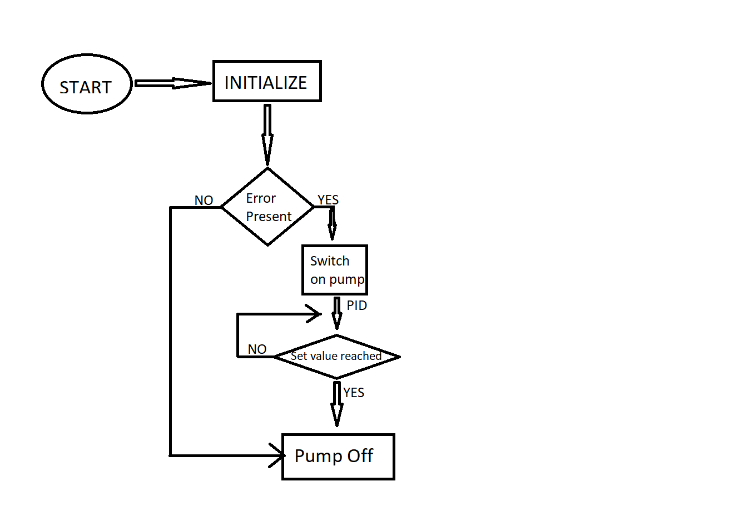

Fig2: Flowchart

The above figure explains the flow of processes in this experimental set up. PID algorithm is being integrated into the above system. Here PID is used to give appropriate output for a given error.

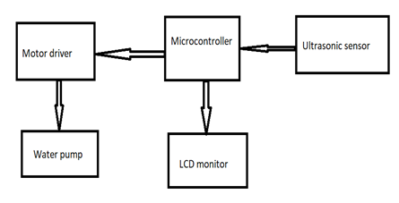

Fig2: Block Diagram

Here the microcontroller used is Arduino. Ultrasonic sensor is connected to the arduino. Arduino recievs the liquid level from ultrasonic sensor. If set point is above the current level water pump is switch on. Motor driver is use to supply required current and to regulate the voltage. LCD display indicates the current water level and set water level

##### C:\Users\Deepak Sethupathy\Desktop\liquid.png_bb.png

Fig4: Circuit Diagram

#### VI. PID GRAPH ANALYSIS

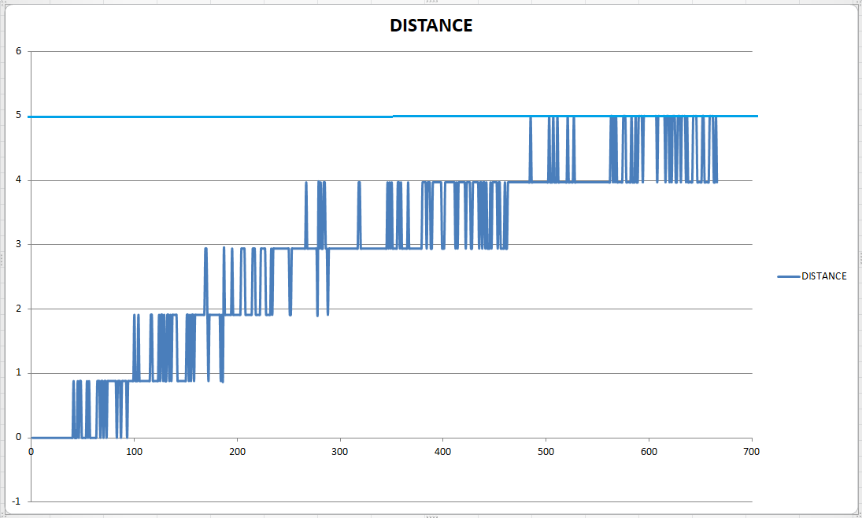

Fig5: Distance vs Time graph

##### C:\Users\Deepak Sethupathy\Desktop\Output.PNG

Fig6: Output Voltage vs. Time graph

We can observe in Fig:5 that as time increases the water level increases towards 5. Here the set point is 5. Fig 6 is the output voltage vs time graph. According to PID control the output voltage should decrease with decrease in error. This can be clearly inferred from Fig6.

PID Parameters for Fig5 are: Kp=4 Ki=6 Kd=7

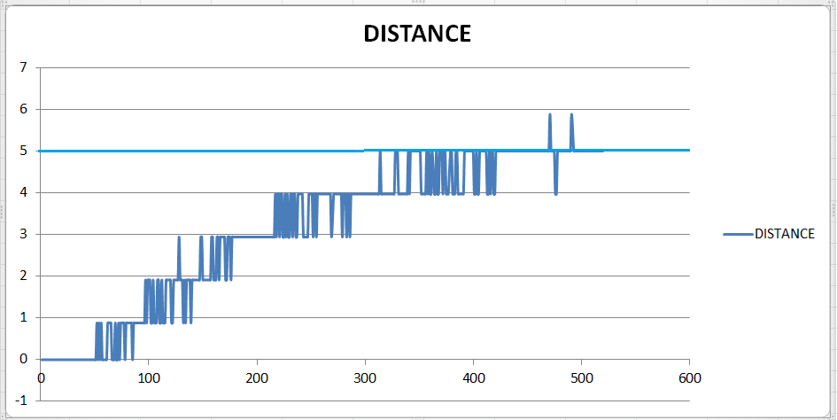

Fig7: Distance vs. Time graph

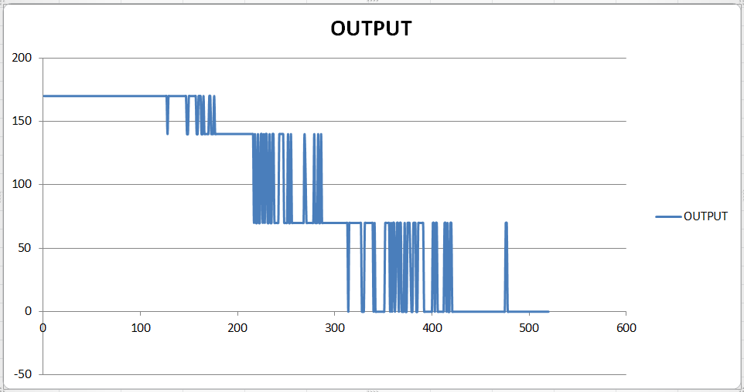

Fig8: Output Voltage vs. Time graph

PID Parameters for Fig7 are: Kp=10 Ki=6 Kd=7

For the above graph Kp value was increased to 10. It can be observed that set value is reached much faster than Fig:5. There is also few overshoots due to increased Kp.

#### VII. BILL OF MATERIALS

|  |  |  |  |
| --- | --- | --- | --- |
| Serial number | Product | Quantityper order | Cost in rupees |
| 1 | Arduino uno | 1 | 419 |
| 2 | HC-SR04 Ultrasonic sensor | 1 | 255 |
| 3 | L298N Motor Driver | 1 | 238 |
| 4 | RG1602A LCD display 16x2 | 1 | 170 |
| 5 | Potentiometer | 5 | 250 |
| 6 | Jumperwires | 120 | 210 |
| 7 | Submersible 3-6V water pump | 1 | 210 |
| Total cost | | 1752 | |

#### VIII. CONCLUSION

Interfacing of hardware components with arduino through coding is done successfully. Detection of liquid level by Ultrasonic sensor and corresponding PID switching of Motor Pump is achieved. Graphs for different PID parameters were plotted and studied.

##### References

1. WATER CONSERVATION[online]. Available: <http://cgwb.gov.in/Bhujal-manthan/Water%20Conservation.pdf>J. Clerk Maxwell, A Treatise on Electricity and Magnetism, 3rd ed., vol. 2. Oxford: Clarendon, 1892, pp.68-73.
2. F. Ma, "An improved fuzzy PID control algorithm applied in liquid mixing system," *2014 IEEE International Conference on Information and Automation (ICIA)*, Hailar, 2014, pp. 587-591.  
   doi: 10.1109/ICInfA.2014.6932722
3. P. M. Meshram and R. G. Kanojiya, "Tuning of PID controller using Ziegler-Nichols method for speed control of DC motor," *IEEE-International Conference On Advances In Engineering, Science And Management (ICAESM -2012)*, Nagapattinam, Tamil Nadu, 2012, pp. 117-122.
4. Deign Gloria Jose and Shalu George K, “Modelling and Controller of Liquid Level system using PID controller”

.